Antarctic sea ice loss linked to changes deep in the ocean
  - After decades of becoming fresher and lighter, Antarctic Intermediate Water is becoming saltier, denser and deeper

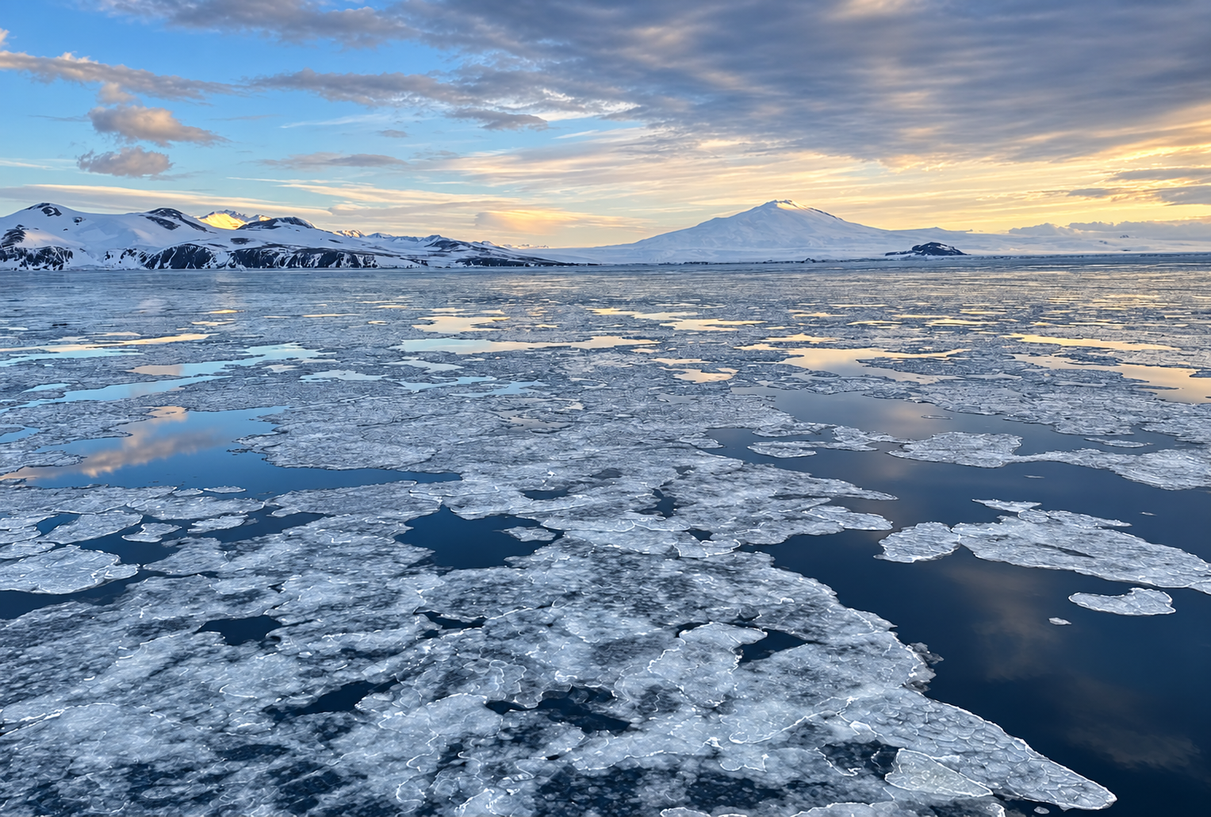
Cover image. Sea ice off Victoria Land, Antarctica, with Mount Melbourne in the background. Image credits: Alberto C Naveira Grabato
A major water mass that spreads from Antarctica into the Indian Ocean is changing. After decades of becoming fresher and lighter, Antarctic Intermediate Water has been becoming saltier, denser and deeper since 2016.
A new study, involving researchers at the Indian Institute of Science in Bengaluru, the University of Melbourne and the University of Southampton, links this reversal to the sharp decline in Antarctic sea ice after 2015. The findings are scheduled for publication in Nature Climate Change.
Antarctic Intermediate Water is found roughly 700 to 1,200 metres beneath the surface. It spreads northwards from the Southern Ocean into the Atlantic, Indian and Pacific oceans, carrying the properties it acquires near Antarctica into the tropical oceans.

How the reversal happened
The connection starts with seasonal sea ice. As the ice melts in spring and summer, it adds fresh water to the ocean surface. Cooling and mixing also help form the waters that sink beneath the surface and spread north as Antarctic Intermediate Water.
From at least the 1970s through 2015, this water mass became progressively fresher and lighter. Our analysis indicates that declining sea ice reduced the seasonal meltwater supply. With less fresh water available, the earlier trend reversed.
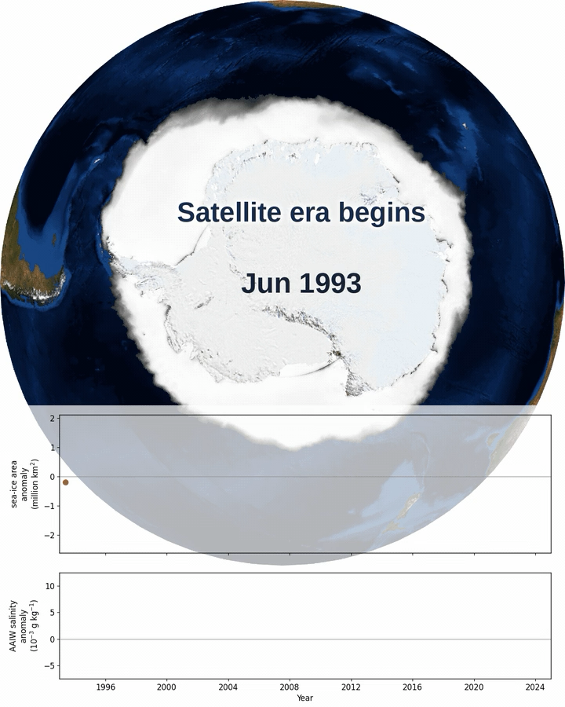

Image: Monthly satellite-observed Antarctic sea-ice concentration maps (top) and sea-ice area anomaly (bottom), 1993–2024, showing gradual expansion until 2015 and an abrupt decline thereafter.

To track the change, we used about 20 years of measurements from Argo, an international network of robotic floats that record ocean temperature and salinity. The floats send their measurements back by satellite when they surface.
Along with these measurements, we also used satellite observations of sea ice and separate ocean reanalyses covering 2004 to 2024.
All three records showed freshening through 2015, followed by saltier, denser and deeper Antarctic Intermediate Water from 2016 onwards. The strongest changes occurred in the South Atlantic.
The speed is striking. Ocean sediment records show similar reorganisations associated with past glacial–interglacial transitions over thousands of years. The current reversal has occurred within about a decade, although the comparison does not establish equal changes in scale or identical causes.

Why does it matter
This water helps shape the ocean’s density structure, which influences how heat moves between surface and deeper waters. The ocean absorbs more than 90% of the excess heat accumulating in the climate system. Changes in where it stores that heat can matter for the climate above it.
Changes in this structure could affect how heat is distributed between the surface and deeper waters, with possible consequences for ocean circulation. The scale and timing of those effects remain uncertain.
There may also be implications for India’s monsoon: separate modelling research links Southern Ocean heat uptake to South Asian monsoon circulation. Whether this water-mass reversal could influence that process remains untested.

What needs to be measured next
The priority is to follow the changing water as it spreads north and determine how it affects oceans’ vertical structure and heat storage. Models will also need to capture the sea-ice decline and its effects more accurately before researchers can assess possible regional consequences.
We do not yet know whether the reversal will persist or whether freshening could return. Sustained observations are needed to distinguish a lasting shift from a shorter-lived fluctuation.
Sustained ocean observations will help us track these changes and understand their wider effects.

Author biographies
Kaushik Mishra is a PhD researcher at the Centre for Atmospheric and Oceanic Sciences and the Divecha Centre for Climate Change, Indian Institute of Science.
Bishakhdatta Gayen is an associate professor at the Centre for Atmospheric and Oceanic Sciences, Indian Institute of Science and ARC Future Fellow and associate professor in mechanical engineering at the University of Melbourne.
Alberto Naveira Garabato is Regius Professor of Ocean and Earth Science at the University of Southampton.

Study reference
Mishra, K., et al. “Reversal of Antarctic Intermediate Water trends triggered by sea ice decline.” Nature Climate Change. Scheduled publication: 28 October 2026. DOI: 10.1038/s41558-026-02758-y

